## Welcome

Welcome to the OCI-Terraform workshop to create a secure architecture for ADW/ATP

## Pre-requisites

### Install Terraform

<https://www.terraform.io/downloads.html>

## Architecture Diagram

This is what we’ll be provisioning with Terraform

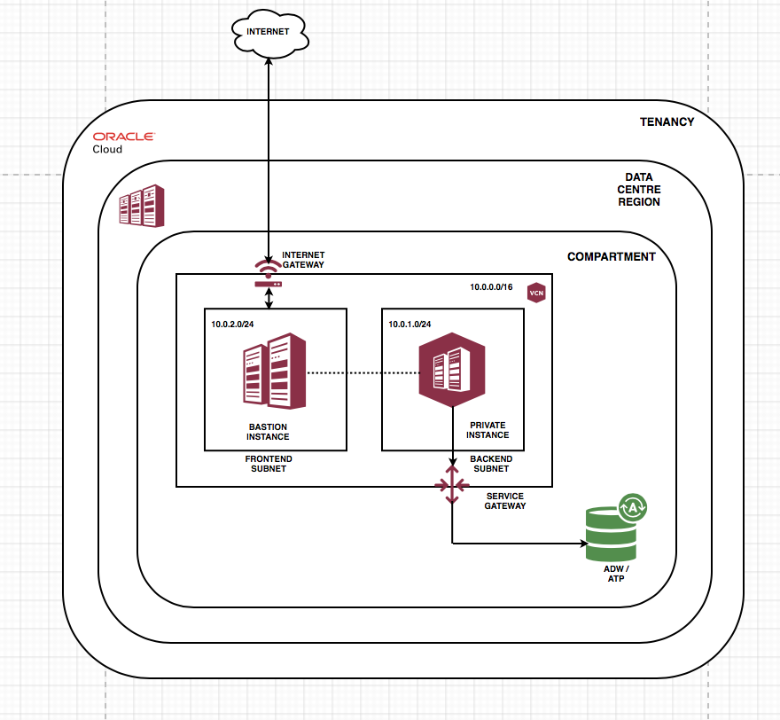

## Customize Environment Variables

First, change directory to "Repo/terraform"



#### Replacing Tenancy OCID environment variable

Sign into your OCI tenancy using your OCI credentials (tenancy name, username, and password)

Upon entering the OCI Console, hover your mouse over the user menu in the top right corner. From the resulting drop-down list, and click on Tenancy: .

The OCI Console’s main dashboard.

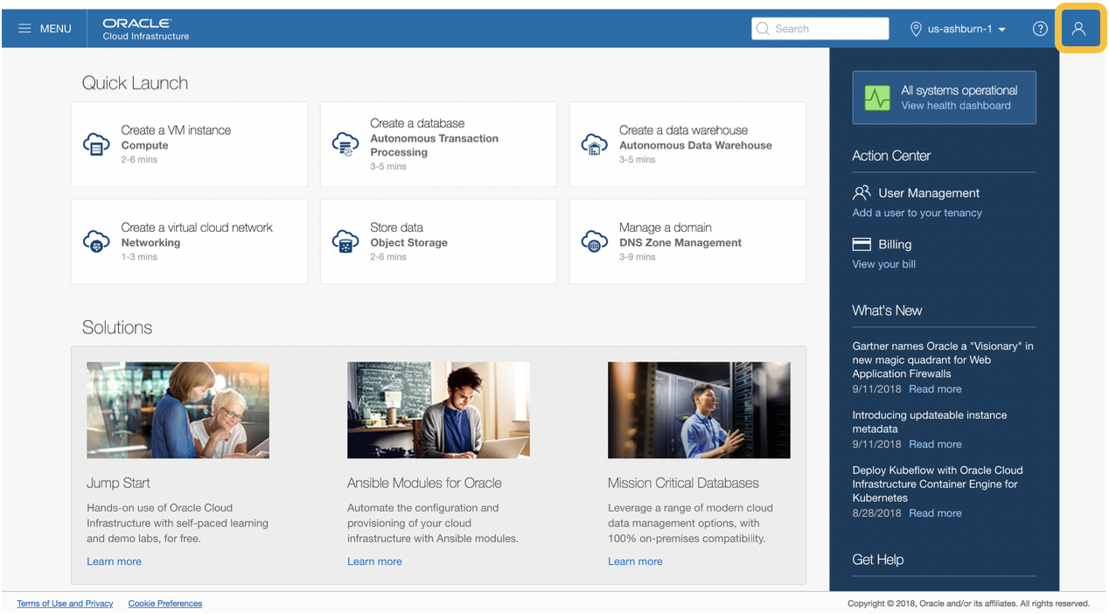

Choosing our tenancy.

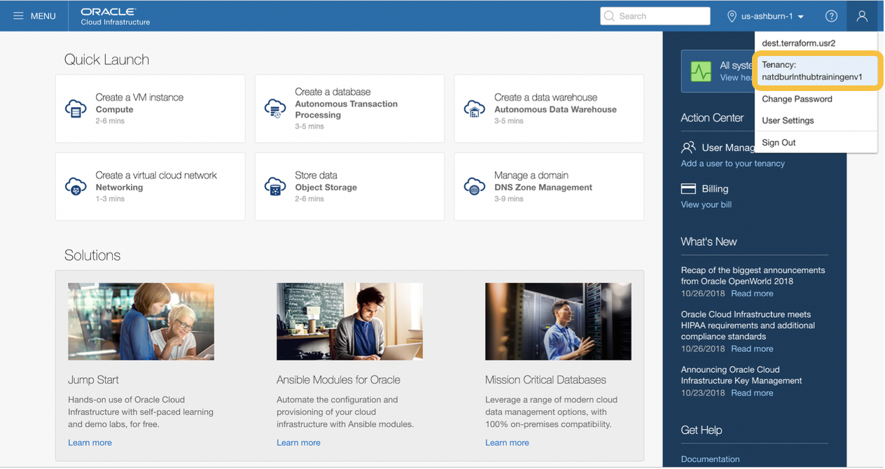

Copying our tenancy OCID.

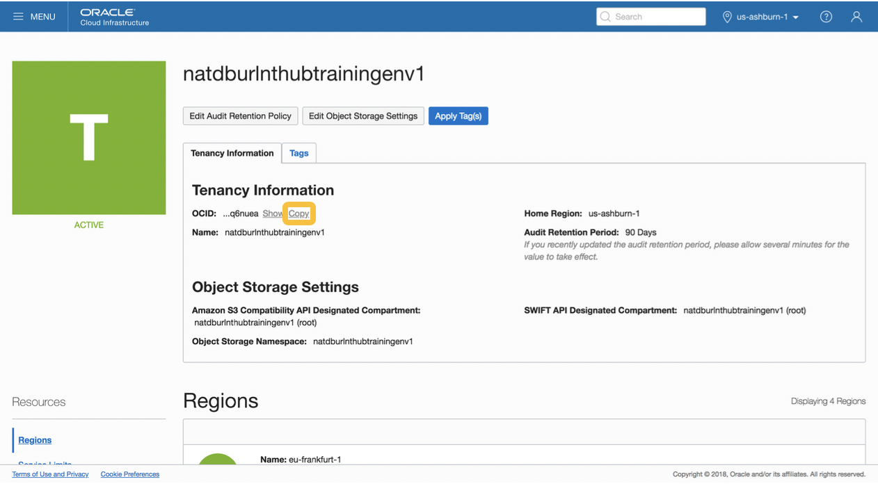

In env.sh, paste your tenancy OCID in its designated position.

#### Replacing Region OCID environment variable

Return to the OCI Console. Under the Tenancy Information section, find Home Region listed, and copy the string to the right of it to your clipboard.

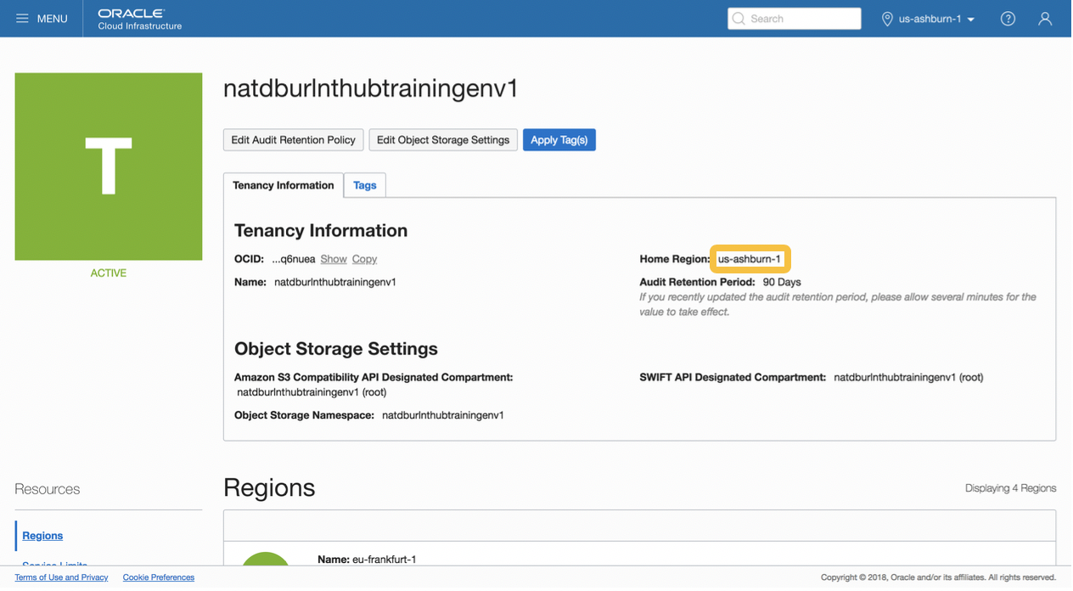

In env.sh, paste the string in its designated position.

#### Replacing User OCID environment variable

Return to the OCI Console. Click on the hamburger menu at the top left corner of the console’s main dashboard.

Choosing User Settings.

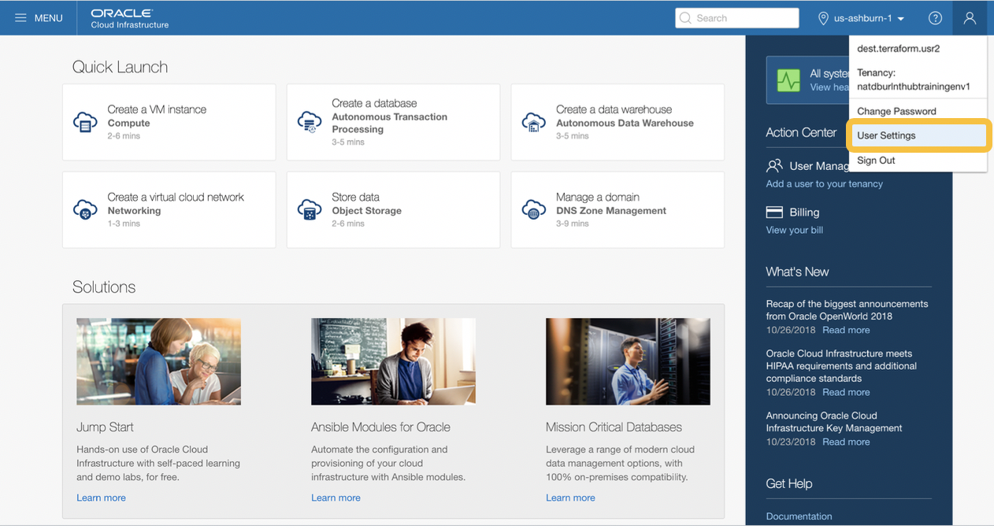

Copying our user OCID.

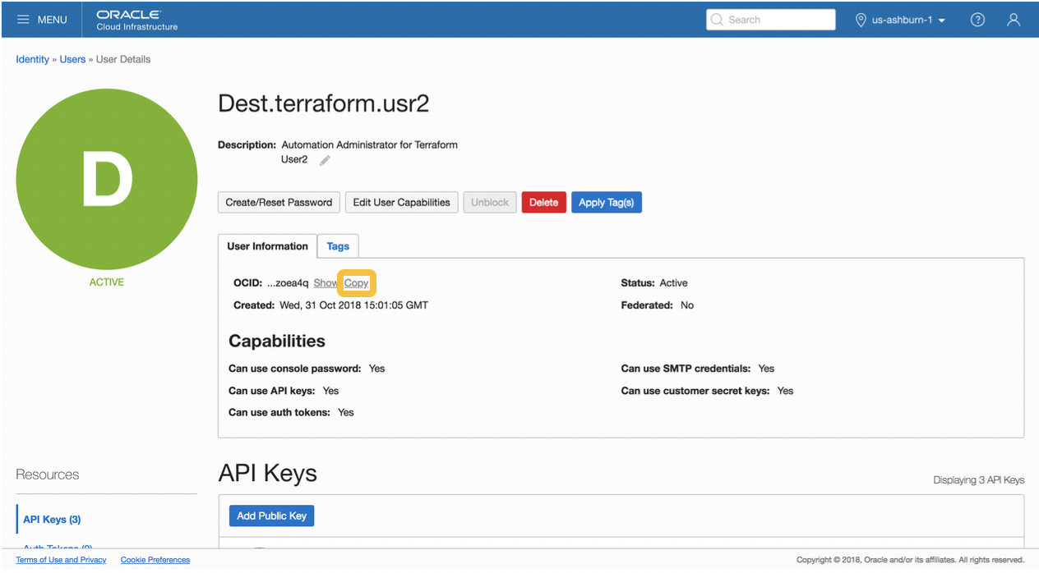

In env.sh, paste your user OCID in its designated position.

#### Uploading API Key to OCI

Change directory into '../.oci'



Copy the oci_api_key_public.pem to your clipboard to copy the contents of the file containing your API public key.



Return to the OCI Console, and click on the blue button that reads Add Public Key.

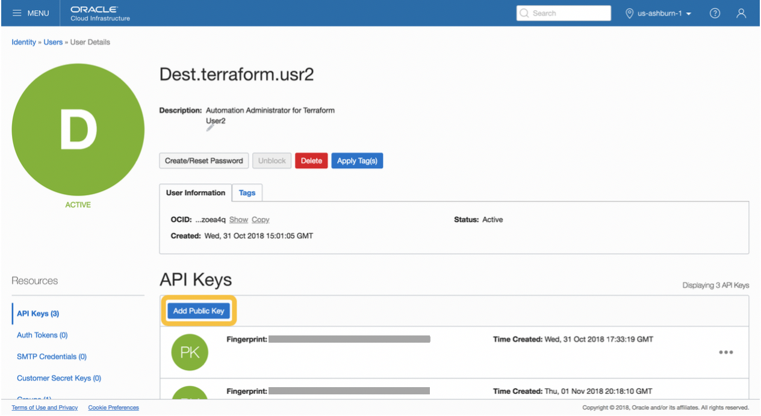

Paste your API public key into the field, and click Add.

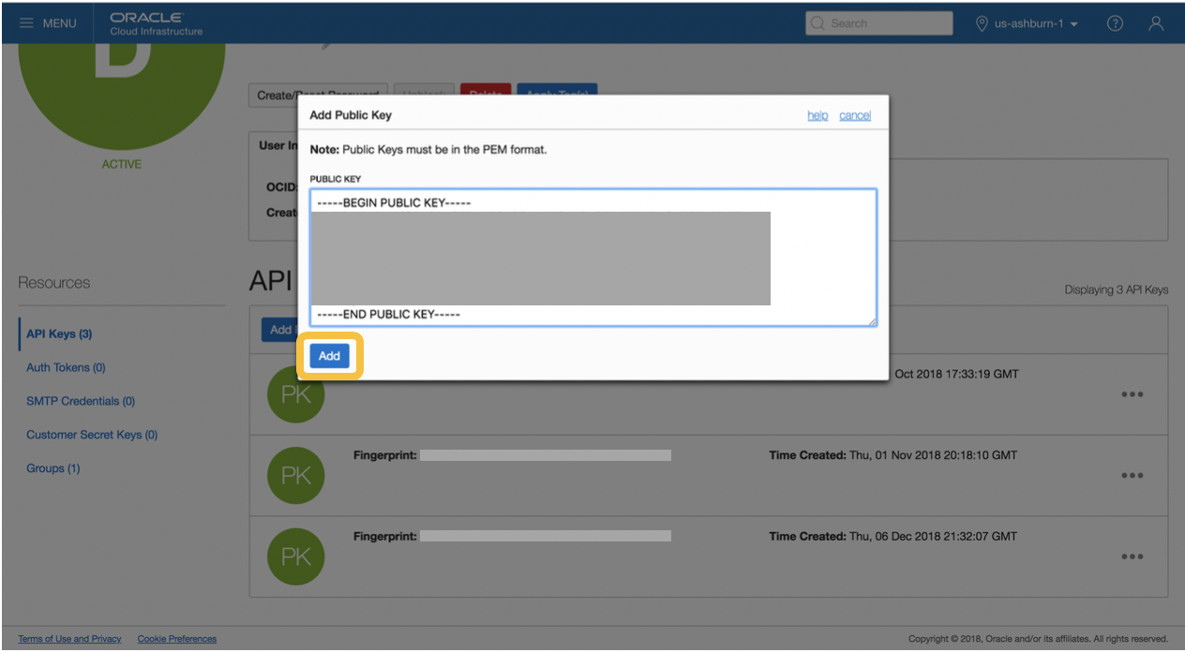

Under the API Keys section, find the resulting fingerprint

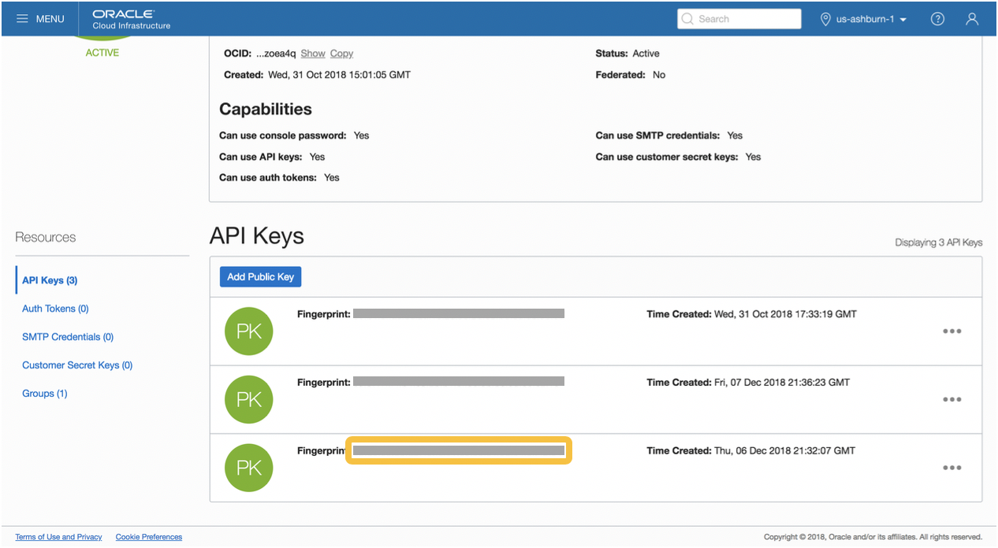

You are now authenticated to use Terraform with your OCI tenancy!!!

## Save Environment Variables

Run this command to save environment variables to command line interface instance



## Clean Terraform Script

Run these few commands to clean up Terraform repository to make sure no elements of previous deployments are needed.



## Run Terraform Script

Initialize the Terraform project



Plan the changes to your Terraform project



Apply changes to your Terraform project. The variable "input_service" will either be "atp", standing for Autonomous Transaction Processing or "adw", standing for Autonomous Data Warehouse. The variable "input_service_name" will be the name for the Autonomous Transaction Processing or Autonomous Data Warehouse.



##### [Optional]

This Terraform project currently has default attributes that can be changed easily inside vars-root.tf. For example, you can change the display name of the Frontend (Public) instance simply by replacing the word "Bastion_Instance"